3rd Grade Supply List
Surline Elementary School
Necessities - Please label with your child’s name
4 spiral bound note books ($0.20 at Wal-Mart on Sale)
2 Folders with fasteners
Pencils with erasers
Small pencil bag or box
Pens
Highlighter
Dry Erase Markers
Glue Sticks

Optional:
Markers
Crayons: 24 count or smaller
Scissors
Colored Pencils
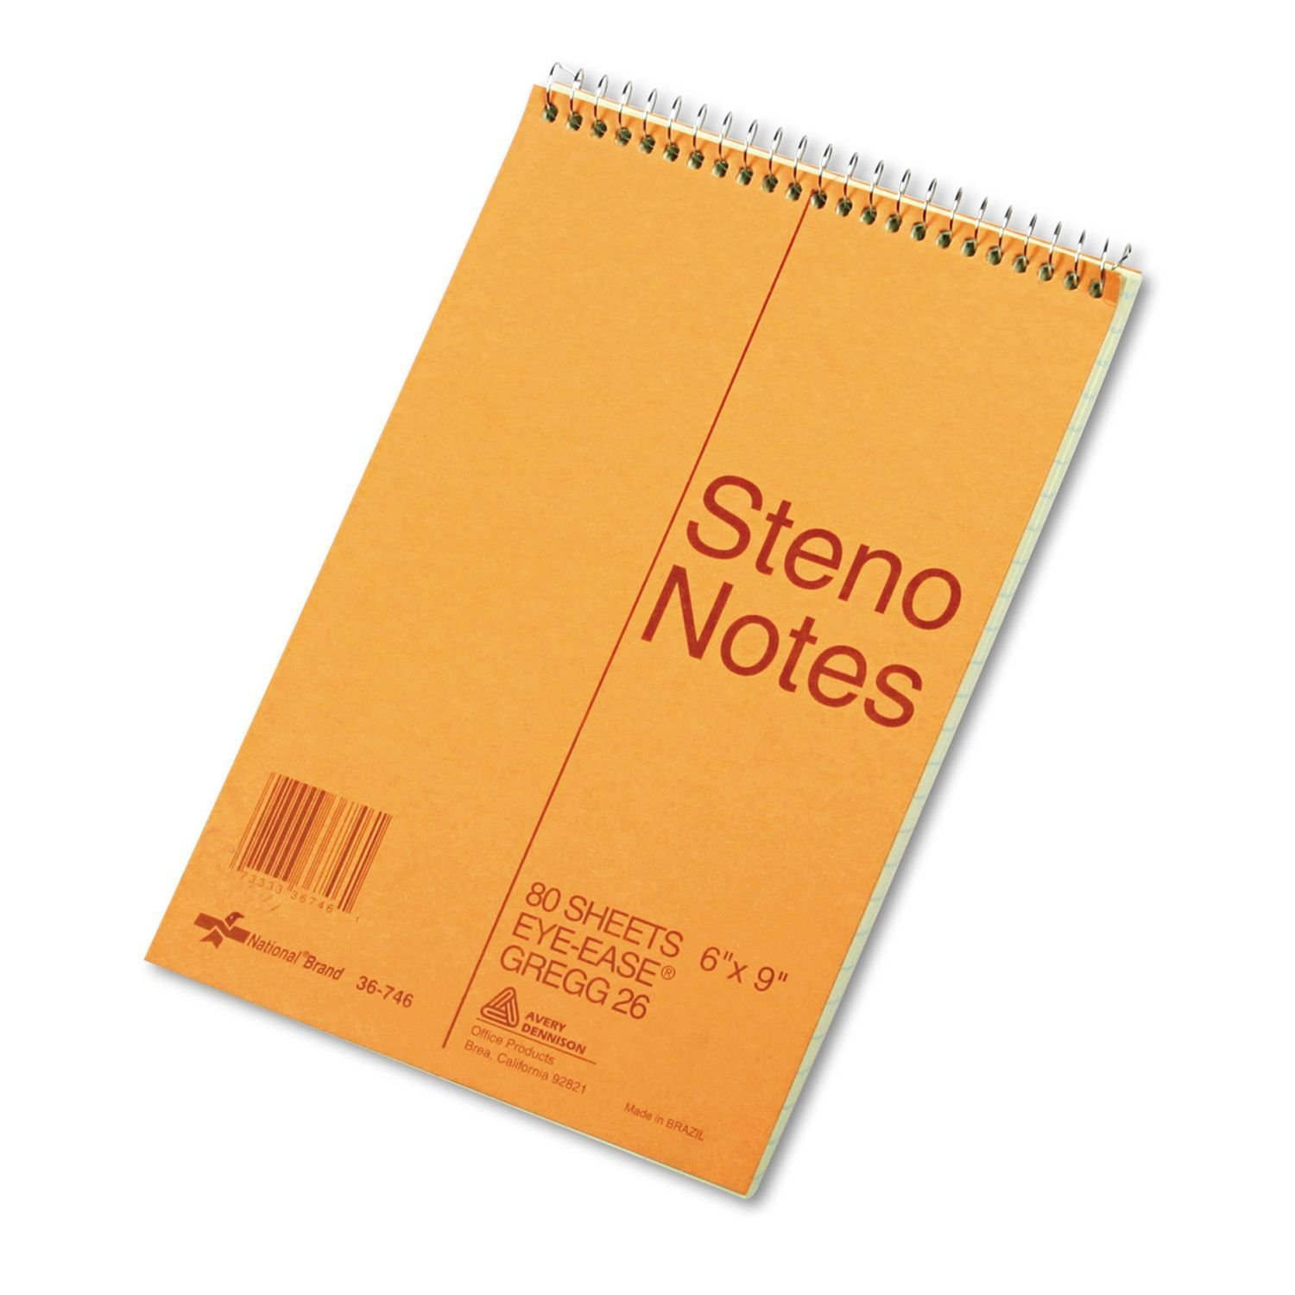
Mrs. Chamberlain and Mrs. Bragg:
6”x9” Stenographer (steno) Notebook

You may also choose to donate the following items for all class use:
- Tissue
- Disinfectant Wipes
- Post-It Index Tabs
- Markers
- Glue sticks
- Scissors
- Pencils
- Dry Erase Markers

We will have a time for snack each day. Please feel free to send your child with a nutritious snack each day….this really boosts our brain power!
Thank you! Third Grade Teachers

